Multiple-choice section

|  |  |  |  |  |  |  |  |  |
| --- | --- | --- | --- | --- | --- | --- | --- | --- |
| Question | 1 | 2 | 3 | 4 | 5 | 6 | 7 | 8 |
| Answer | D | B | D | D | A | B | B | C |

Question 1 [3.1]

D

** × 16 = 12 donuts

Question 2 [3.1]

B

**= 4 ÷ 2 = 2

Question 3 [3.1]

D

The smallest difference between one of the listed fractions and 1 is:

 ( + = 1)

Question 4 [3.2]

D

HCF of 14 and 20 = 2

** ÷ ** = **

Question 5 [3.4]

A

**

= 

=  = 

Question 6 [3.3]

B

1 = , 2 = 

So  is greater than 1, but less than 2.

Question 7 [3.5]

B

 of $35

= × 

= $7

Question 8 [3.6]

C

 ÷ 

=  × 

= 2

Multiple-choice total marks: 8

Short answer section

Question 9 2 marks [3.1]

(a) The denominator is the bottom number in a fraction, below the fraction bar.

(b) A mixed number has a whole number part and a fraction part.

Question 10 1 mark [3.1]

Question 11 2 marks [3.2]

(a) (b)

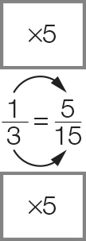 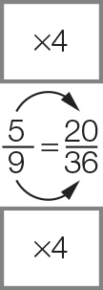

Question 12 8 marks [3.3]

|  |  |
| --- | --- |
| (a) (i) LCD = 15  (ii)  (iii) <  (iv) So < | (b) (i) LCD = 21  (ii)  (iii) >  (iv) So > |

Question 13 9 marks [3.4]

|  |  |  |
| --- | --- | --- |
| (a)  +  =  +  = | (b)  −  =  −  =  = | (c)  +  =  +  =  = |

Question 14 6 marks [3.5]

|  |  |  |
| --- | --- | --- |
| (a)  of $20 =  ×  =  = $15 | (b)  of  =  ×  = | (c)  ×  =  = |

Question 15 6 marks [3.6]

|  |  |  |
| --- | --- | --- |
| (a) 2 ÷  =  ×  =  = 6 | (b)  ÷  =  ×  =  = 1 | (c)  ÷ 3 =  ×  = |

Short answer total: 34

Extended answer section

Question 16 5 marks [3.1, 3.4, 3.5]

(a) (i)  =  (ii)  = 

(b)  = 

(c)  × 12  
=   
= 3 removed, so 9 left

Question 17 9 marks [3.1, 3.2, 3.3]

(a) 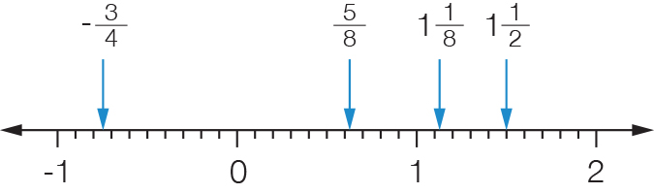

(b)  =+ =   
 = + = 

(c) (i) 2 = 2 ×= 

(ii) 2 = 2 × = 

(d)  is closest to .

(e) is the smallest as it is the only negative number.  
 is next as it is a proper fraction, followed by , then .

Extended answer total: 14

TOTAL test marks: 56